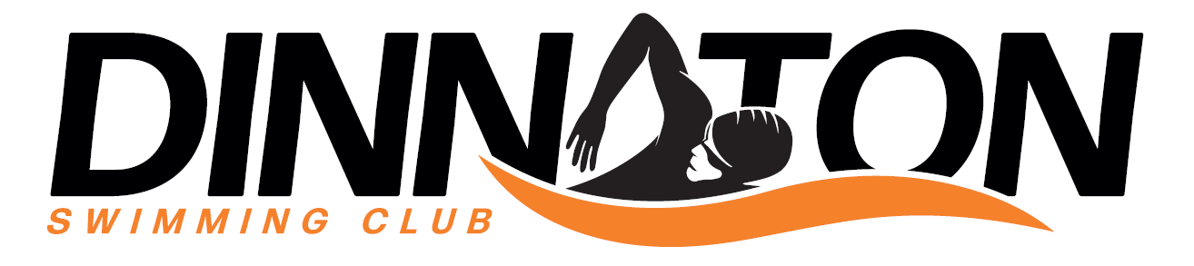

SOCIAL MEDIA POLICY AGREEMENT

- Purpose

This social media Policy ("the Policy") provides guidelines for the appropriate use of social media platforms by employees and representatives of Dinnaton Swimming Club. The intent of this Policy is to protect our organization's reputation, promote consistency across our communication channels, and outline the professional responsibilities of our employees when using social media.

2. Scope

This Policy applies to all employees, contractors, volunteers, and other individuals who represent Dinnaton Swimming Club, both within and outside office hours.

3. Policy

3.1 All official use of social media on behalf of Dinnaton Swimming Club must be approved by Committee prior to posting.
3.2 Employees are expected to adhere to the same standards of conduct online as they would offline. This includes adherence to our Code of Conduct, Privacy Policy, and all other internal policies.
3.3 Any use of Dinnaton Swimming Club's name, logos, or other brand materials must be approved by Committee.
3.4 Confidential information, including proprietary data or personal details of clients or employees, should never be shared on social media.

4. Personal Use of Social Media

4.1 Employees are permitted to associate themselves with Dinnaton Swimming Club when posting on their personal social media accounts, but they must clearly brand their online posts as personal and purely their own.
4.2 Any content that may be perceived as potentially defamatory, damaging, or negative toward Dinnaton Swimming Club should not be posted on personal or professional social media accounts.
4.3 Employees must ensure that their social media activity does not interfere with their work commitments or productivity.

5. Consequences for Inappropriate Use of Social Media

5.1 Any violation of this policy may lead to disciplinary action, up to and including termination of employment.
5.2 Legal consequences may also apply if employees engage in activities that are illegal, defamatory, or violate the rights of others

6. Training and Resources

Dinnaton Swimming Club will provide social media training and resources as needed to help employees understand their responsibilities under this policy.

7. Reporting

Employees should report any concerns or violations of this policy to the Committee.

8. Review and Amendment of the Policy

This Policy will be reviewed and updated as necessary to ensure its effectiveness and alignment with Dinnaton Swimming Club's strategic objectives. By using social media in relation to Dinnaton Swimming Club, you agree to abide by this Policy. We thank you for respecting these guidelines.

9. Conclusion

This social media policy has been designed to promote productive, respectful, and legal use of social media within Dinnaton Swimming Club. It serves to protect the organization's reputation, uphold our values, and comply with all relevant laws and regulations. Compliance with this policy is mandatory for all employees, contractors, and representatives of Dinnaton Swimming Club. Violations will not be taken lightly and may lead to disciplinary actions, up to and including termination of employment. For questions or clarifications regarding any aspect of this policy, please contact the Committee.

Name & Signature of Member
Date

